Blob Storage

* Files
* Binary data
* Optimal way to store data for jobs

Queue Storage

* Durable queue for large-volume cloud services
* Messaging queueing
* Data access with REST APIs

Table Storage

* NoSQL key-value store
* Semi structured data that’s highly available
  + Flexible data schema
  + But massively scalable

# Storages

Publicly available, with a unique URL (eg. When you create a Table, it can be accessed through a URL)

Redundancy:

* LRS: locally redundant storage
  + Data in eg. 3 places, **but withing the same physical data center** (1 availability zone)
* ZRS: zone redundant storage
  + 3 availability zones (same price as LRS)
* GRS: geo redundant storage
  + More expensive, 6 copies of data (outside of region)
* RA-GRS: read-access geo redundant storage
  + We have access to GRS data with this (to read it back)
  + App must use secondary URL to access it

Access tiers:

* Cool: we keep data for 30 days (cheaper to store, more expensive to access it) 🡪 good for backups
* Hot: default, standard read-write, performance, data avaialble anytime
* (Archive: we keep data for 180 days, but it takes hours to get to read that data [up to 24h])

We can host static websites in a storage account

Storage accounts can store TABLES (other than Blobs, Files and Queues)

* Primary Key is calculated from two values
  + Partition Key: tables are partitioned to support load balancing (entities are organized by partitions). First part of PK.
  + Row Key: Second part of PK. Unique identifier for an entity within a given partition. Together the PartitionKey and RowKey uniquely identify every entity within a table.  
    The row key is a string value that may be up to 1 KB in size.  
    You must include the RowKey property in every insert, update, and delete operation.

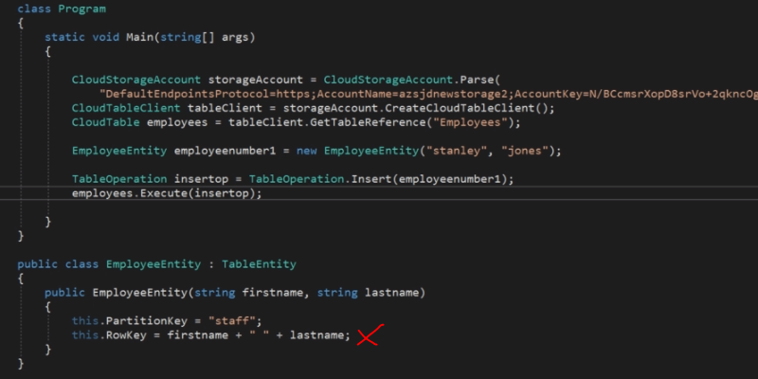





**What is the difference between Managed Storage and Storage Account when it comes to pricing?**

Managed Storage is provisioned to a size, you pay for that size whether its used or not  
(not true for Storage Account, there’s IO cost)